**LABORATORY PROGRAM – 11**

Write a program to traverse a graph using BFS method.

**OBSERVATION :**

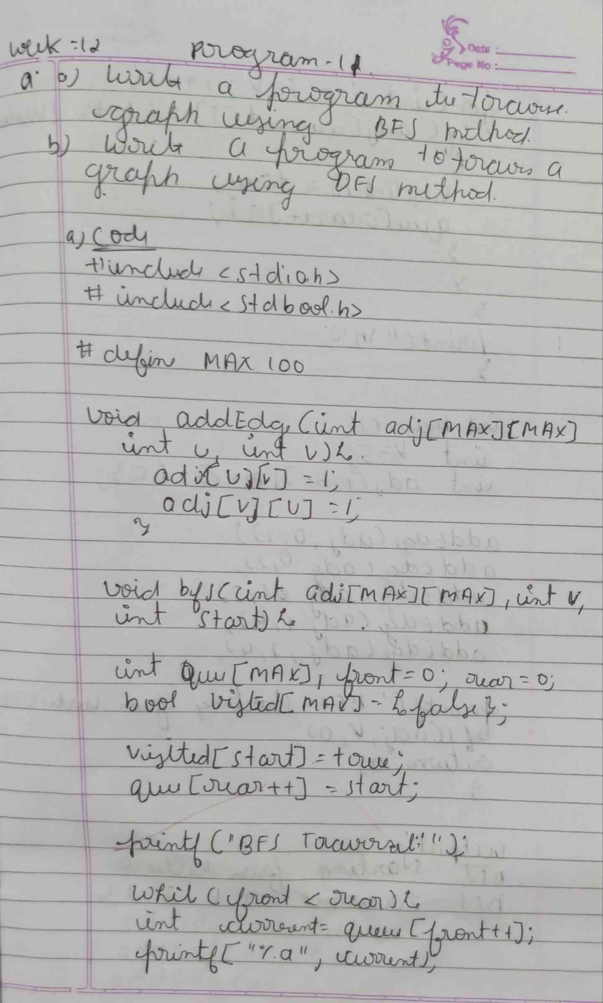

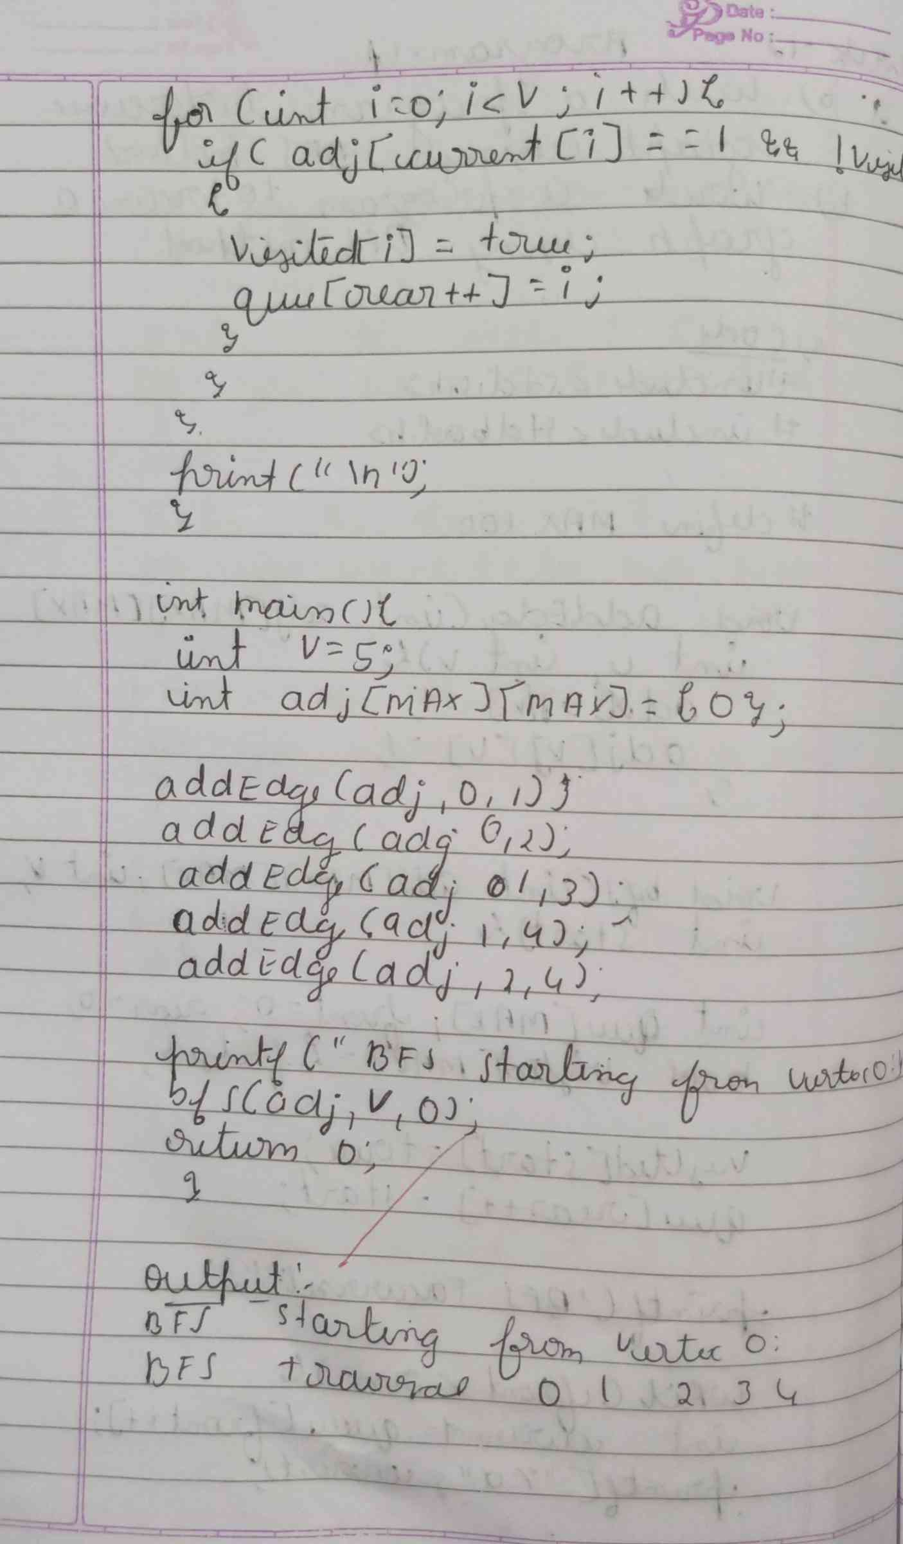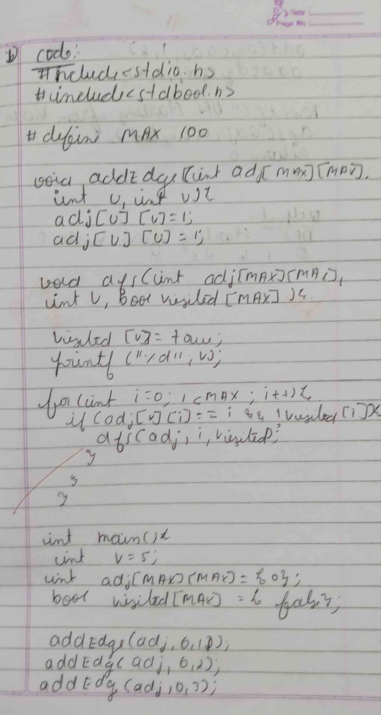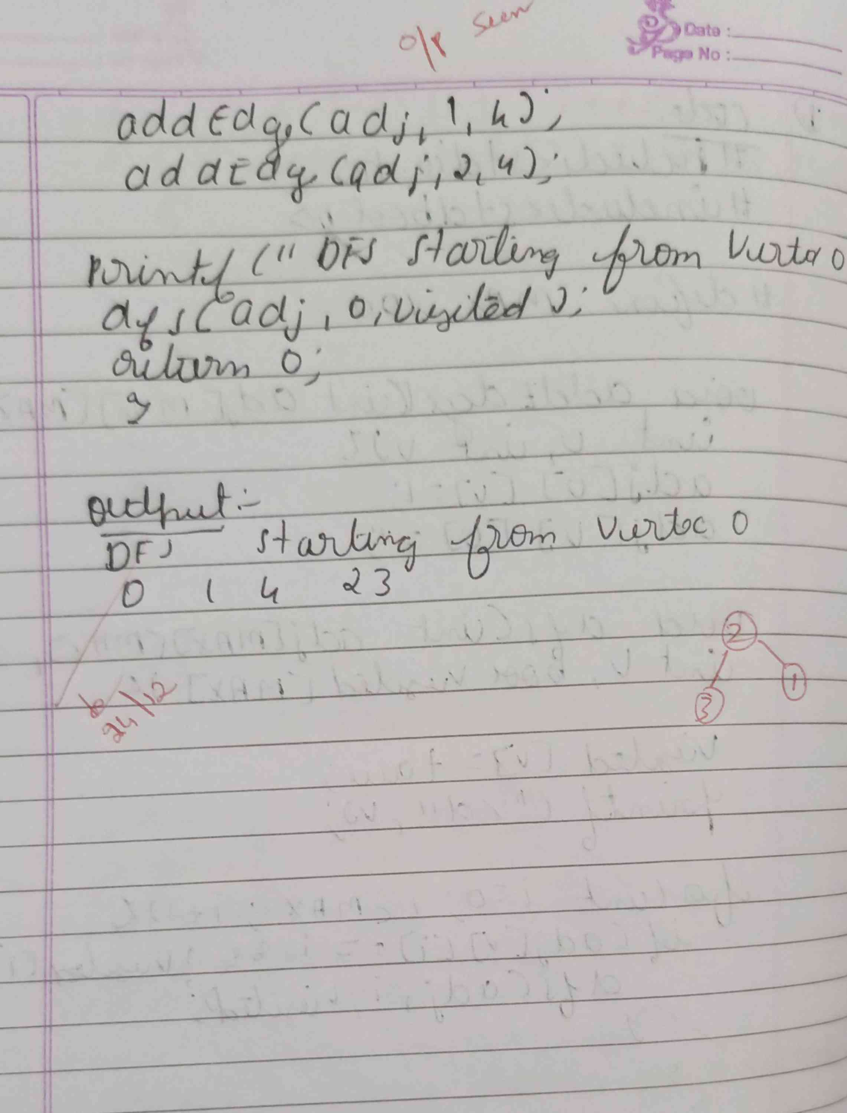

**CODE :**

**#include <stdio.h>**

**#include <stdbool.h>**

**#define MAX 100**

**void addEdge(int adj[MAX][MAX], int u, int v) {**

**adj[u][v] = 1;**

**adj[v][u] = 1;**

**}**

**void dfs(int adj[MAX][MAX], int v, bool visited[MAX]) {**

**visited[v] = true;**

**printf("%d ", v);**

**for (int i = 0; i < MAX; i++) {**

**if (adj[v][i] == 1 && !visited[i]) {**

**dfs(adj, i, visited);**

**}**

**}**

**}**

**int main() {**

**int V = 5;**

**int adj[MAX][MAX] = {0};**

**bool visited[MAX] = {false};**

**addEdge(adj, 0, 1);**

**addEdge(adj, 0, 2);**

**addEdge(adj, 0, 3);**

**addEdge(adj, 1, 4);**

**addEdge(adj, 2, 4);**

**printf("DFS starting from vertex 0:\n");**

**dfs(adj, 0, visited);**

**return 0;**

**}**

**OUTPUT :**

